Initial image with the connector properly seated, THIS IS GOOD

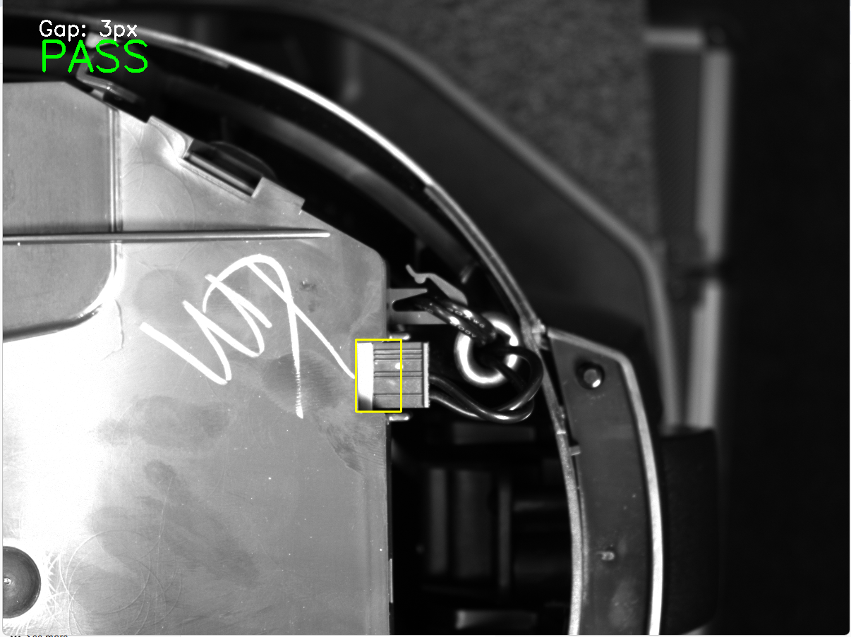

THEN I MOVED THE CONNECTOR BACK, IT IS NOT SEATED PROPERLY THIS IS BAD
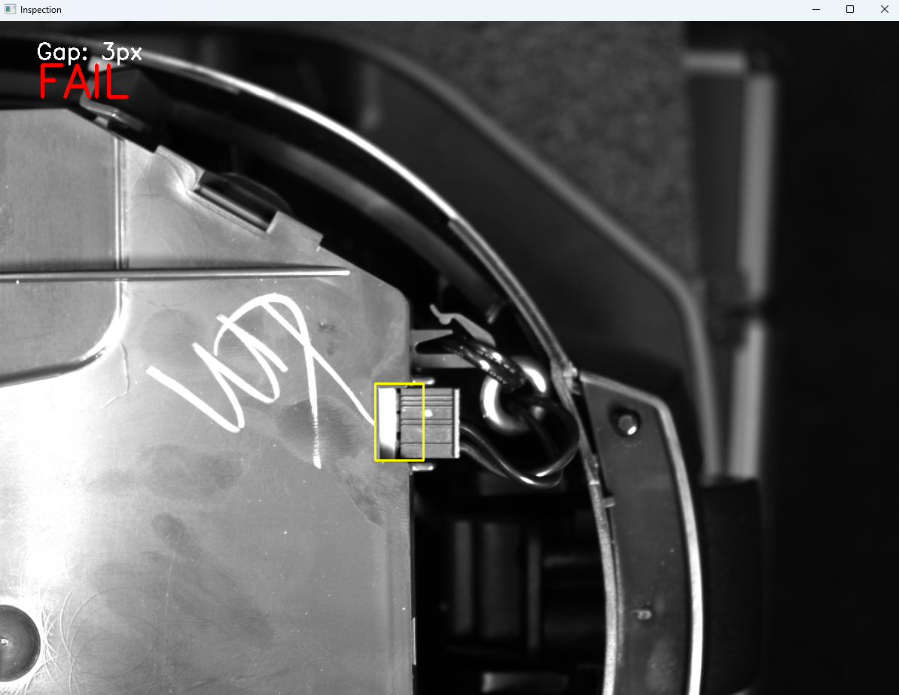

THEN I MOVED THE CONNECTOR BACK IN PLACE SO IT IS PROPERLY SEATED, THIS IS GOOD

